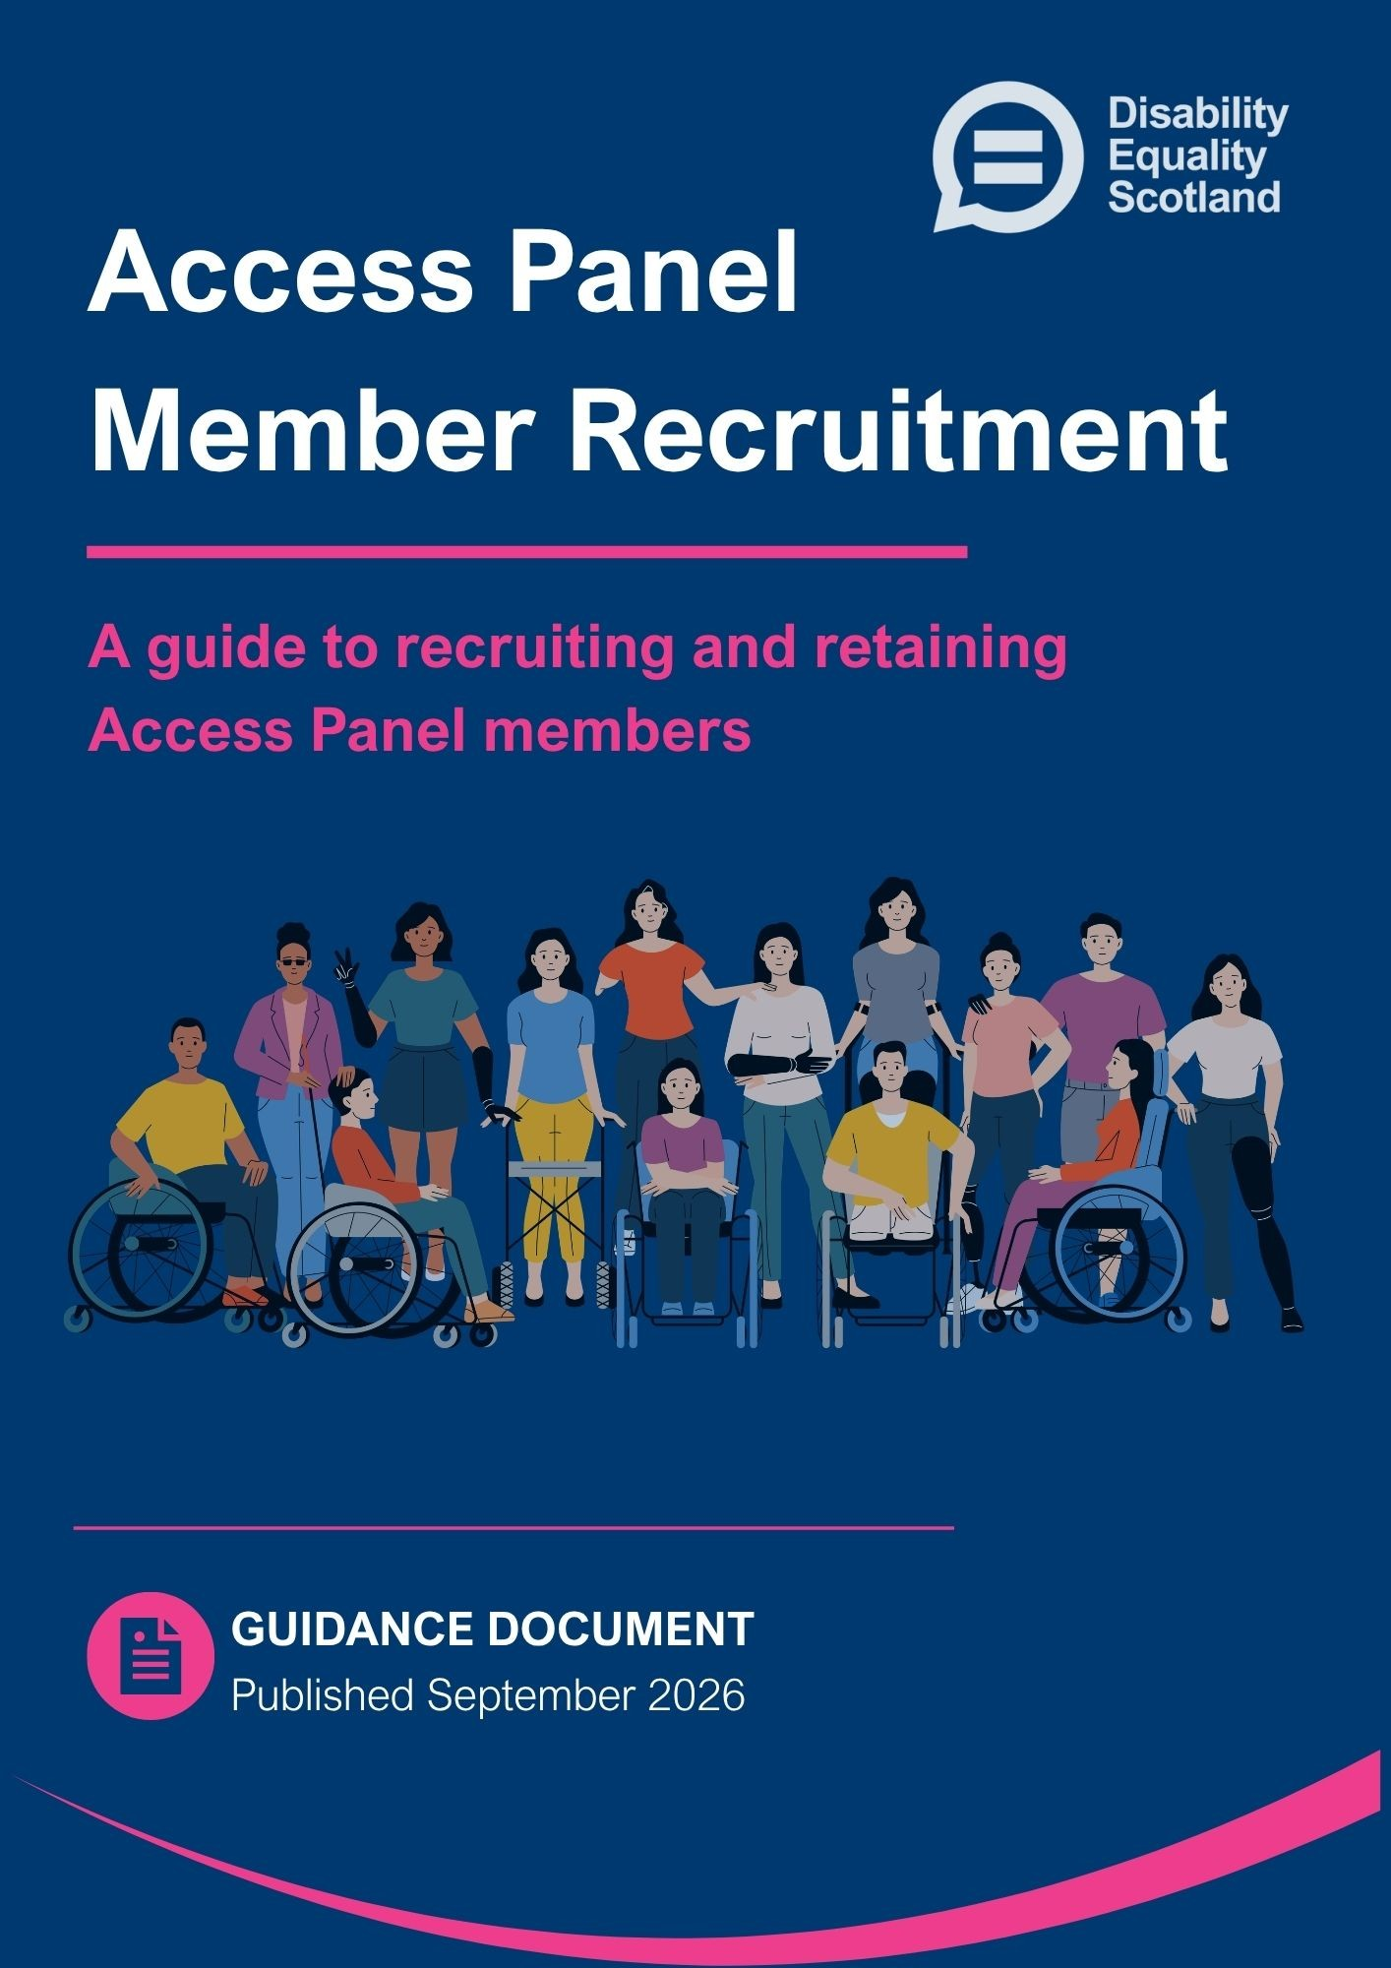

Contents
​
Summary Checklist: Quick Guide for Access Panels 3
Introduction 4
Before Recruiting 5
What will members do? 5
What are the benefits of being a member? 5
Who can become a member? 7
Other planning considerations 7
Supporting Policies and Documentation 8
Data Protection 9
Recruitment Strategy 10
Recruitment Approaches 11
1. Asking People Directly 11
2. Community Wide Recruitment 12
3. Targeted Recruitment 12
4. Social Media Recruitment 13
5. Posting on your website, Disability Equality Scotland website and through third parties 17
Case Study: Badenoch and Strathspey Access Panel 19
Following Up on Interest 21
Managing Unsuccessful Applications 22
Creating a Positive Experience for New Members 23
Further Resources 24
Appendix A: Data Protection Helpful Hints 25
Appendix B: Example Recruitment Materials 27
​


Quick Guide: Access Panel Recruitment Checklist

Before Recruiting
- Understand who you need and why
- Prepare clear messages and accessible materials
- Confirm who will handle enquiries
- Update policies, role descriptions and agreements
- Ensure there are clear and secure ways to process personal data

Recruitment Methods
- Ask people directly
- Promote through your local Third Sector Interface
- Display posters locally
- Use targeted recruitment where needed

Good Practice
- Keep messages simple
- Share recent achievements
- Respond quickly and warmly to any interest
- Welcome diversity and different access needs
- Offer flexibility
- Review what works and update materials regularly

Introduction
This recruitment pack is for both new and existing Scottish Access Panels who want to find new members. Every Access Panel is different. This guidance is designed to be used flexibly. You do not need to read it from start to finish. Start with the summary checklist, then go to the section that matches what your Access Panel needs to do next.
To develop this resource, we drew on best practice and guidance from organisations with expertise in volunteer recruitment. We also engaged with Access Panels across Scotland, whose feedback has helped shape this pack and ensured it reflects approaches that have worked elsewhere.

Before Recruiting
Before starting any recruitment, it helps to be clear about what you need and what you can offer.

What will members do?
It is important to think about what new members will do, and the support they will receive.
Think about:
- What will members do?
- What skills are needed?
- How much time will members need to give?
- What does your Access Panel want to do?
- What support will new members get, such as an induction or training?
- Is this a trustee role?

What are the benefits of being a member?
Telling people about the benefits of being an Access Panel member can encourage them to join.
Benefits might include:
- Learning new skills
- Building confidence
- Being part of a community
- Meeting new people
- Making a difference locally
- Having fun
- Health and wellbeing benefits
- Improving the daily lives of disabled people locally and nationally
Helpful hint: sharing real examples of your Access Panel’s impact can highlight the benefits of joining.

Who can become a member?
A strong Access Panel brings together people with different experiences and skills.

This could include:
- Disabled people with lived experience of different access needs
- People from different age groups, backgrounds, and cultures
- People who represent disability or community organisations
- People with an interest in accessibility and inclusion
- People with useful skills or experience, like communication, social media, community engagement, planning, or access auditing

Helpful hint: bringing together people with different lived experiences and skills helps ensure the Access Panel reflects the community it serves.

Other planning considerations
Taking time to plan can help create a clear and positive recruitment experience.

Think about:
- Who will be the main point of contact?
- Will expenses be reimbursed?
- When is the best time to recruit?
- Do you have a recruitment budget?
- Who will oversee the recruitment process?

Supporting policies and documentation
Having the right policies and documents helps ensure members feel supported, valued, and clear about their role.
Volunteer Policy
Most Access Panel members are volunteers. A volunteer policy is a written document that outlines the role of volunteers, their rights, and the organisation’s expectations.


Click this purple link to see Volunteer Scotland guidance about making a volunteer policy

Volunteer Agreement
Volunteer agreements help organisations and volunteers know what to expect from each other.

Click this purple link to see Volunteer Scotland guidance about creating a volunteer agreement

A Volunteer Role Description
A volunteer description outlines the responsibilities, skills, and expectations for individuals.

Click this purple link to see Volunteer Scotland guidance about creating a volunteer role description.

Trustee and Office Bearer Roles
Trustees and officer bearers play an important role in Access Panels. Clear role descriptions and effective recruitment approaches can help Panels attract new members for future succession planning.
Click this purple link to see the The Scottish Council for Voluntary Organisations support for trustees.

Data Protection
The UK General Data Protection Regulation (UK GDPR) and the Data Protection Act 2018 set out how organisations must handle personal data. The UK GDPR establishes the core principles for processing personal data, including fairness, lawfulness, transparency, accuracy, security, and data minimisation. The Data Protection Act 2018 supports the UK GDPR by providing additional detail on how data protection rules apply in the UK and how they are enforced.

Click the purple link for the UK Legislation: General Data Protection Regulation (GDPR) guidance
Click the purple link to see the UK Legislation: Data Protection Act 2018

During recruitment, Access Panels are likely to handle personal data like people’s names, contact details, addresses and relevant experience. This information should be collected and stored securely, used only for recruitment purposes, and accessed only by those who need it. Personal data should be kept accurate and up to date and retained only for as long as necessary.

Helpful hint: decide in advance who will have access to personal information, where it will be stored, and how long it will be kept.

The Information Commissioner’s Office (ICO) is the UK’s independent authority for data protection and provides guidance and support to organisations on meeting their data protection responsibilities.

Click the purple link to see the Information Commissioner’s Office website for more information

See Appendix A for more information on data protection.

Recruitment Strategy
Before recruiting, identify what you want to say, and where best to say it.

Think if you need any of the following:
- Clear, accessible materials like posters, leaflets, emails, and social media posts
- Simple wording that explains who you are, what you do, and how people can join
- Links to more information or a named contact person
- A workshop or coffee morning where potential members can come along and find out more about the Panel.

Disability Equality Scotland can help by offering templates for recruitment materials (see Appendix B for examples). Email us if you would like to know more: access@disabilityequality.scot

Helpful hint: having a clear message helps avoid jargon and makes recruitment easier.

Recruitment Approaches
Access Panels can use a mix of recruitment methods. The best approach is to use methods that are clear, accessible and build on local relationships.
Helpful hint: link up with your local Third Sector Interface who should be able to offer support and connect you with other organisations.

Click the purple link to see the Third Sector Interface (TSI) Scotland network website for a list of all the TSIs across Scotland.

1. Ask People Directly
This is often the simplest and most effective method.
You might:
- Talk to people you know
- Send flyers to local contacts
- Host an open day or coffee morning
- Ask current members to share opportunities with their friends and networks
Strength: people are more likely to understand your Access Panel and feel welcomed.
Limitation: if used alone, it may limit the diversity of experience of potential members.

2. Community wide recruitment
This casts a wide net and raises awareness in the community.
Examples include:
- List opportunities with your local Volunteer Centre
- Put up posters in libraries, doctor surgeries, supermarkets, community centres and cafés
- Put an advertisement in the local paper
- Attend local events to speak directly with the public
Strength: reaches many people.

Limitation: can be less efficient than targeted approaches for recruiting
members with specific skills or availability.

3. Targeted Recruitment
Useful when you need specific skills or experiences.
Methods include:
- Deliver short talks or presentations on your work to community groups
- Advertise in local newsletters
- Use social media platforms like Facebook
- Contact disability organisations, young people’s groups (colleges, universities) or carers’ services
Strength: brings in people with particular skills.

Limitation: requires planning and time.

4. Social Media Recruitment
Social media can be a simple and cost-effective way to reach new members, especially if your Access Panel already has an established social media presence or access to local community groups with established social media. If you do not have social media accounts with followers, it can take time to build an audience, so it often most effective when used alongside other recruitment methods. You do not need to be an expert. Short, regular posts work best.
Strength: cost-effective way to reach a wide audience and share opportunity quickly.
Limitation: less effective without an established following and excludes people who do not use social media.
Where to Post

Facebook
Facebook is widely used by people of all ages across Scotland and works well for local engagement.
You could advertise on:
- Your own Access Panel’s Facebook page (if you have one)
- Local community groups (most areas have Facebook groups for towns, villages or neighbourhoods)
- Local disability groups or carer groups
- Community centre, library, or council-run pages
- “What’s On in [Your Area]” type group

Helpful hint: on social media always check group rules before posting and avoid posting personal contact details.

Instagram
Instagram is a visual platform and works well for raising awareness and reaching people who may not already be involved in local groups.
Instagram is useful for:
- Sharing photos from events or meetings
- Posting short videos explaining what the Panel does
- Reaching younger people and students
- Showing the positive impact of being involved
Helpful hint: use clear images, short captions, and local hashtags. Hashtags act as themes which allow people to find your posts. For example, #YourTown and #AccessPanelName
Bluesky
Bluesky can be useful for reaching organisations and decision-makers, but it is not as good for local community engagement. Panels may want to use it as part of a mix, alongside platforms like Facebook.

Bluesky is useful for:
- Raising general awareness of your Panel’s work
- Reaching disability organisations, and campaign groups
- Sharing short updates or event announcements
- Tagging local organisations so your post is shared more widely
Helpful hint: posts work best when short, visual, and positive. Regular engagement helps increase visibility

LinkedIn
LinkedIn enables more targeted and credible outreach to people and organisations interested in supporting formal voluntary initiatives.
LinkedIn can help reach:
- Professionals interested in accessibility
- People with skills in IT, design, communications or policy
- Students or graduates looking for volunteering experience
- Local businesses that may want to support the Panel
Helpful hint: share why volunteering with an Access Panel builds skills and experience.
What to Post
You do not need to post a lot. Keep messages simple and friendly.
You could post:
- A short post explaining who you are and inviting people to join
- Photos from previous events (with permission)
- Examples of recent achievements
- Posters or graphics about member opportunities
- Positive quotes or stories from existing members
- Invitations to attend an open meeting
Helpful hint: people respond well to real stories and images rather than long text.
Effective Social Media Recruitment
Applies whatever platform you use.
Keep posts short, and clear
- Explain what the Access Panel is, why it matters, and how to get in touch.
- Use plain language and short sentences.

Use accessible design
- Use high contrast, plain backgrounds and readable fonts.
- Add in alt text for images and image description.
- Capitalise multi-word hashtags (e.g. #AccessibilityForAll).

Include clear contact details
- Add an email address or a link to your website so people know how to get involved.

Post regularly and share successes
- Post every few weeks to help keep your Panel visible.
- Share your impact to encourage people to join.

Increase reach through sharing
- Tag relevant organisations such as local disability groups, Third Sector Interface, and the local authority.
- Ask current members to share posts.

Safety and Moderation Tips
  - Avoid sharing personal information publicly.
  - Use a shared Access Panel email rather than personal accounts.
  - Turn off comments on posts if you prefer or monitor them occasionally.
  - Keep replies polite, friendly, and brief.

5. Posting on your website, Disability Equality Scotland website and through third parties
As well as social media, your Access Panel can also reach people by sharing information on websites and through partner organisations.

Your Panel’s Website (if you have one)
Adding a simple page or news post about recruitment helps people find you through online searches. In a post you could include:
- A short explanation of what the Panel does
- Who you are looking for
- How to get in touch
- What current members enjoy about being the Panel
- Any upcoming meetings or open days
Helpful hint: keep the page up to date so people know the Panel is active.

Disability Equality Scotland Website
Disability Equality Scotland can help Access Panels recruit new members by advertising volunteer opportunities on both their main website and the dedicated Access Panel website, as well through its social media channels. This can help your Panel reach people who are already interested in accessibility and inclusion and may already know about Access Panels.

To help spread the word on the Disability Equality Scotland websites and social media channels email: access@disabilityequality.scot
Third Party Websites and Newsletters
Many local organisations are happy to help share volunteer opportunities, including:
- Local councils and community planning teams
- Third Sector Interfaces
- Local disability charities and support groups
- Volunteer centres and volunteering databases
- Community centres and libraries
- University or colleges (for student volunteering listings)
You can send them a short paragraph and a poster or photo and ask them to include it on their website or in their newsletter.

Helpful hint: provide clear contact details and a short message that people can easily copy and paste.

Case Study: Badenoch and Strathspey Access Panel

Badenoch and Strathspey Access Panel successfully recruited several new members, including office bearers, by using a simple and friendly approach. They focused on building relationships, talking to people in the community, and making it easy for people to get involved.

What they did:

Spoke to local community groups and individuals about what the Access Panel does and how it supports the community.


Held meetings with guest speakers and topics local people were interested in.


Made everyone feel welcome at meetings and asked people to leave their email address or telephone number so they could stay in touch.


Encouraged people to come back to future meetings and to share information about the Access Panel with their networks.


Supported people’s accessibility needs by working with local community transport providers to help people get to meetings.


Supported people to become members and get involved, therefore helping the Access Panel achieve its aims.


Key Learning
By being open, welcoming, and active in the community, the Badenoch and Strathspey Access Panel successfully recruited new members. By building relationships and staying connected with local people they helped raise awareness and encouraged more people to get involved with the Panel.

Following Up on Interest
How you respond to enquiries can make a difference to whether people want to get involved.
Respond promptly
- Decide who will handle member enquiries and ensure they have the time to do so.
- Reply to emails, phone calls, or messages quickly as possible.
- Let people know when a role has been filled or if there are delays.
Make it personal
- Personalise responses where possible using a person’s name.
- Encourage questions and offer additional information about the Access Panel.
- Explain next steps and expected timescales e.g., when the next Access Panel meeting is.

Keep Information up to date
- Keep your website, social media, or promotional material up to date with member opportunities.
Be organised and inclusive
- Keep a simple record of enquiries about communication.
- Ask about access requirements early.
- Send a gentle reminder if someone has not responded.

Managing Unsuccessful Applications
Not everyone will be the right fit for the current needs of the Access Panel. When this happens, it is important to communicate the decision respectfully. The hints below can help Panels respond consistently and fairly.
Hints:
- Be timely - let applicants know as soon as a decision has been made.
- Be kind and respectful - thank them for their interest and time.
- Be clear but brief - avoid over-explaining or justifying the decision.
- Focus on fit, not fault - frame decisions around role requirements, availability or current needs.
- Do not give false hope - avoid language that suggests a role may become available if this is unlikely.
- Keep a record of decisions in line with your recruitment and data protection processes.
- Signpost other ways to get involved – such as your local Third Sector Interface or Volunteer Centre.

What to Avoid
- Giving detailed or subjective feedback unless it is part of your process.
- Referring to protected characteristics (e.g. age, health, disability, background).
- Making informal promises or future commitments.
- Communicating decisions via social media or informal channels.

Creating a Positive Experience for New Members

The way you welcome, include and support new members can make all the difference to their engagement and enjoyment.

Be Welcoming
- Offer an informal chat before they attend a meeting
- Suggest they come along as a guest first
- Explain clearly what the Panel does and what their role could be

Be Flexible
- Not everyone can attend every meeting
- Consider if taking part remotely may be possible
- Small contributions still matter

Be Clear and Honest
- Explain what you can offer
- Describe the time commitment
- Highlight training or support available

Be Inclusive
- Encourage involvement from people of all ages, backgrounds and impairments
- Ensure materials and meetings are accessible
- Ask about access requirements early

Further Resources
- Volunteer Scotland – is the national centre for volunteering in Scotland.
- The Scottish Council for Voluntary Organsation (SCVO) – Aims to support and promote a sustainable voluntary sector.
- Highland Third Sector Interface has created a Good Governance Toolkit which has a section on volunteer recruitment.
- Make your Mark Inclusive Volunteering Toolkit- This toolkit is designed to support voluntary organisations in Scotland to make their volunteering programmes more inclusive.
- Inspiring Scotland Volunteer Network - connecting over 500 professional volunteers with Scotland’s charities to build capacity and strengthen the sector – is a key part of the Inspiring Scotland model.
- OSCR: The 2026 Social Media Guide for Charities - this guide is aimed at staff, volunteers and trustees of charities who want to use social media with confidence.
- Accessible Social Guidebooks - a comprehensive guidebook that takes you through the basics of accessible best practices for social media.

Contact us
If you would further support with member recruitment, please get in touch by:
- Email: access@disabilityequality.scot
- Telephone: 0141 370 0968


Disability Equality Scotland 2026
Scottish registered charity SC031893

Appendix A: Data Protection Helpful Hints
Being careful, respectful, and organised with people’s information goes a long way towards meeting UK GDPR requirements. Below are some helpful hints.
Hints:
- Only collect information you actually need for recruitment and selection.
- Tell people how their information will be used and who will see it.
- Keep personal data secure, e.g. password-protected files, locked cabinets, secure email accounts.
- Limit access to personal data to those directly involved in recruitment.
- Keep information accurate and up to date where possible.
- Store data for only as long as necessary, then delete or securely dispose of it.
- Follow your Access Panel’s data protection or privacy policy, even if it is simple.

What to Avoid
- Collecting unnecessary personal information “just in case”.
- Sharing personal data with others unless there is a clear and lawful reason.
- Leaving personal data unsecured, such as on shared computers, personal devices or public spaces.
- Keeping recruitment information indefinitely once a decision has been made.
- Using personal data for purposes it was not collected for (e.g. marketing).
- Discussing applicants’ personal information outside of the recruitment process.

Appendix B: Example Recruitment Materials
Disability Equality Scotland can help Access Panels design recruitment materials. Below are some example templates.

Poster Graphic
Example 1
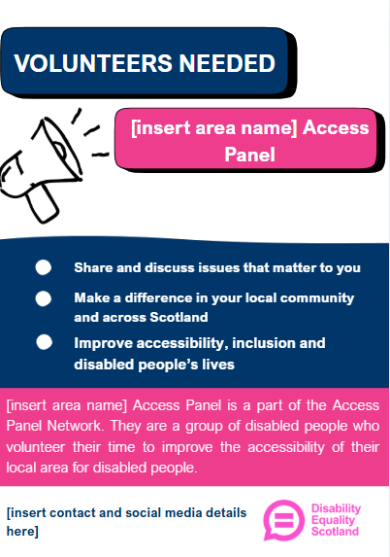

Example 2
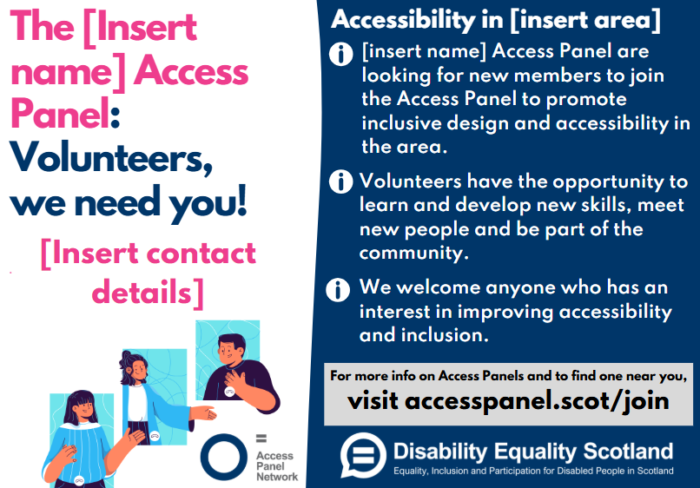

Social Media Graphic
Example 1
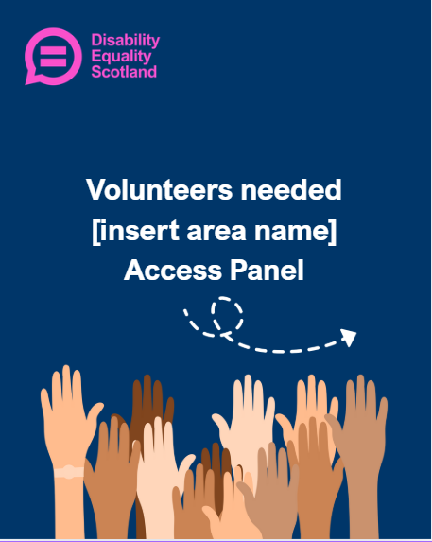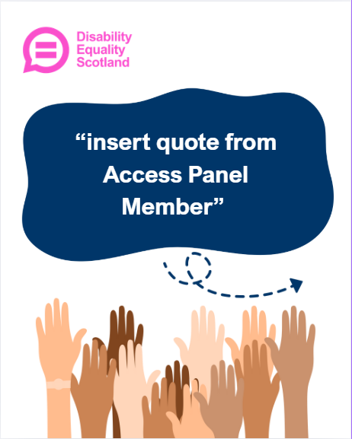

Example 2
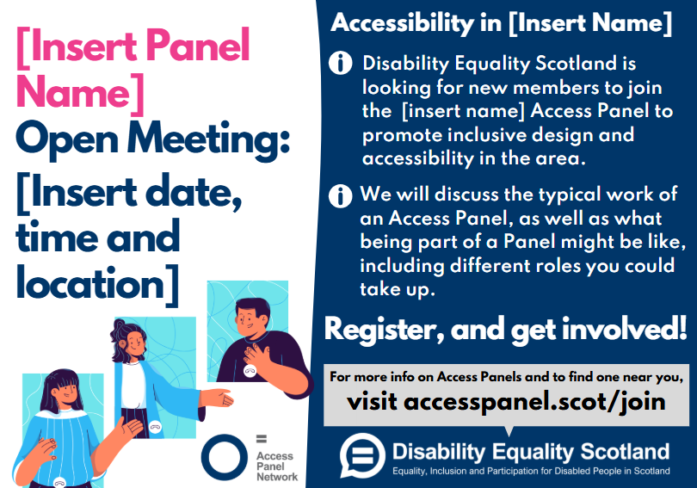

Example social media posts
For Facebook
Option 1
Insert [quote from an Access Panel member about what they enjoy about being involved in the Access Panel].
Have you lived experience of disability, long-term health conditions, or access needs? Or are you passionate about making spaces, services, and communities more inclusive?
[Name of Access Panel] is a small, welcoming group of volunteers who share their experiences and ideas to help improve accessibility and inclusion. By joining you’ll have the chance to:
- Share your voice and lived experience
- Help make services and environments more accessible
- Meet others who care about inclusion and equality
- Be involved in a way that fits around your energy and availability
- Have your voice heard and help shape disability legislation across Scotland
No special qualifications are needed, just an interest in access and inclusion. Support is provided, and we aim to make participation as accessible as possible. If you’d like to find out more or are interested in joining, please comment below or send us a message. We’d love to hear from you!
Feel share this post with anyone who might be interested.
Option 2
We are seeking new volunteers to join our Access Panel and support our work to improve accessibility and inclusion across services and environments. This opportunity is open to people with lived experience of disability, long-term health conditions, or access needs, as well as those with a strong interest in equality and inclusion.
[Name of the Access Panel] provides a structured and supportive forum in which members share insight, feedback, and recommendations to help inform better access. No specific qualifications are required, and participation is flexible to accommodate different levels of availability. We are committed to making involvement as accessible as possible and to providing appropriate support.
If you are interested in joining the Access Panel or would like further information, please comment on this post or contact us directly. We would also appreciate this post being shared with others who may be interested.
For Instagram or Bluesky
Want to help make things more accessible? We’re looking for volunteers to join our Access Panel.
Share your lived experience, help improve inclusion, and be part of positive change.
DM us to find out more

