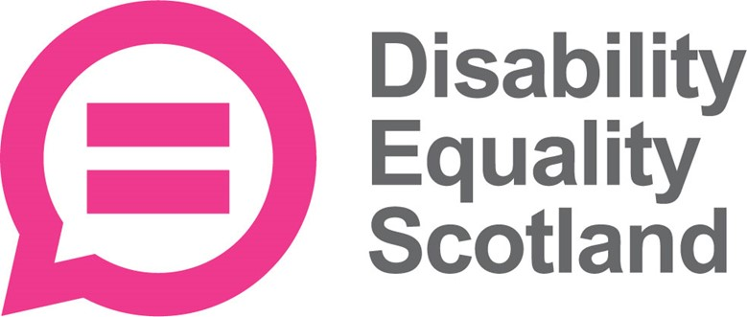

Getting new members to join your Access Panel

Part 1 of 2

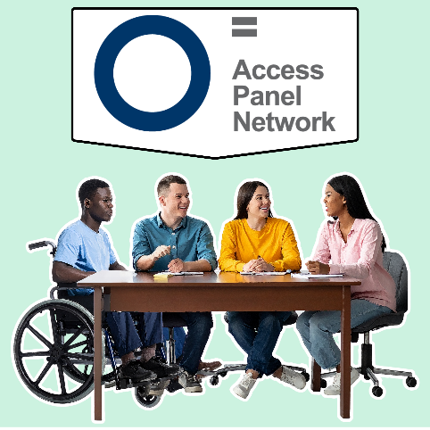


What this recruitment pack is for
This information is for Access Panels in Scotland who want to find new members.
It has ideas, advice and tips.
Recruitment means the way we advertise jobs and how we choose people to do them.

Before recruiting
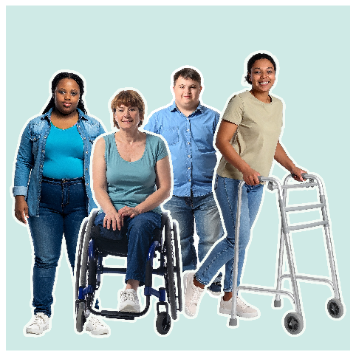 | - understand who you need and why  - make clear messages and information  - decide who will deal with enquiries
 | - make any changes needed to policies, role descriptions and agreements  - have clear ways to keep personal information safe and private
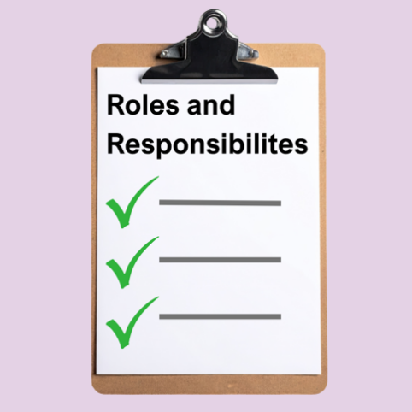 | Before starting any recruitment be clear about what you need and what you can offer.  Think about:  - what will members do?  - is this a trustee role?
 | Trustees are volunteers who lead an organisation and make sure it does what it was set up to do.  They make important decisions about what work the organisation will do.
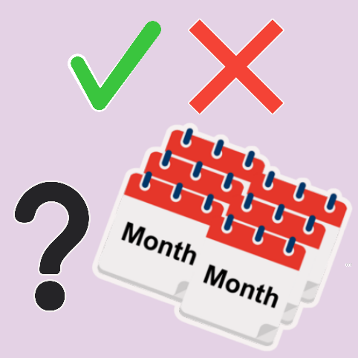 | - what skills are needed?  - how much time will members need to give?  - what does your Access Panel want to do?
 | - What support will new members get – things like induction or training?  Induction is the information people would get when they join an Access Panel.
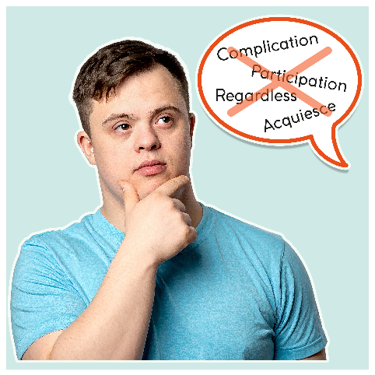 | Helpful hint: using simple, clear language makes information more accessible.  This makes recruitment easier.

What are the good things about being a member?
 | You can encourage people to join your Access Panel by telling them why being a member is a good thing including that they will:  - learn new skills  - build confidence  - be part of a community
 | - meet new people  - make a difference in your local area having fun
 | - it is good for your health and wellbeing – feeling comfortable, healthy and happy  - improve the daily lives of disabled people locally and nationally
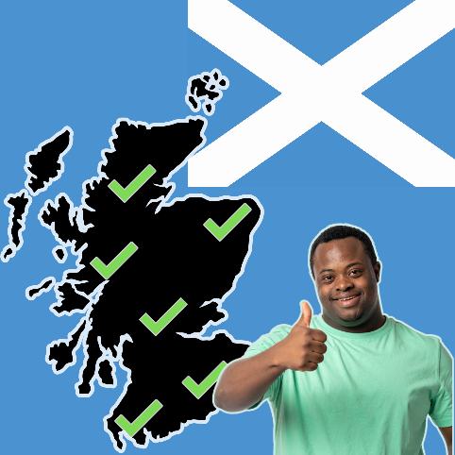 | Helpful hint: sharing real examples of the difference an Access Panel can make in a local area can help to show the benefits.

Who can become a member?
 | A strong Access Panel brings together people with different experiences and skills including people:  - with different access needs  - from different ages, backgrounds, cultures and communities
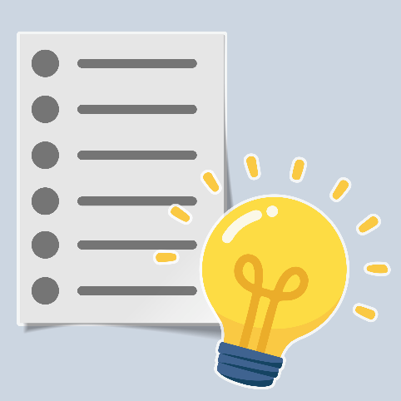 | - who are part of disability or community organisations  - interested in accessibility and inclusion  - with skills or experience like:  - social media and communication  - working with communities  - checking accessibility

Other things to plan
 | Think about:  - who the main contact person in your Panel?  - when is the best time to recruit?  - who is in charge of recruitment?
 | - do you have money to cover the cost of recruitment?  - will people get money back if they spend money to be part of the Panel?
 | Helpful hint: be organised and give new members a positive experience

Policies and documents you will need
 | Having the right policies and documents makes sure that members feel supported, valued, and clear about their role.
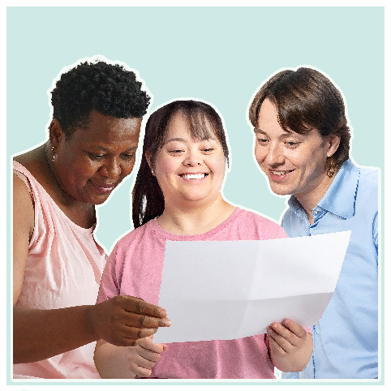 | Volunteer Policy  Most Access Panel members are volunteers – they are not paid for their work.  A volunteer policy explains how volunteers will be involved in the organisation.
 | A volunteer description explains:  - what work they will do  - their rights  - what DES expects of them  Click this blue link to see Volunteer Scotland guidance about making a volunteer policy and description.
Volunteer Agreement
This helps organisations and volunteers know what to expect from each other.
Click this blue link to see Volunteer Scotland guidance about making a volunteer agreement.
 | Trustee and Office Bearer Roles  Charity trustees are volunteers who:  - lead a charity and make sure it does what it was set up to do  - make important decisions about the work of the charity
 | Office bearers have a specific duty or job in a group like a Secretary or Chairperson.  Clear role descriptions and good ways of recruiting:  - can help Panels attract new members for future work  - help organisations and volunteers to know what to expect from each other
 | Click the blue link for information from The Scottish Council for Voluntary Organisations about supporting trustees.

Data Protection – keeping information safe and private
 | Laws called The UK General Data Protection Regulation (UK GDPR) and the Data Protection Act 2018 show how organisations must handle personal data.
 | Helpful hint: decide who will have access to personal information, where it will be stored, and how long it will be kept.
 | Being careful, respectful and organised with people’s information will support you to follow GDPR rules.  What to do:  - only collect information you need for recruitment and selection  - tell people how their information will be used and who will see it  - keep personal information in password-protected files, locked cabinets or in secure email accounts
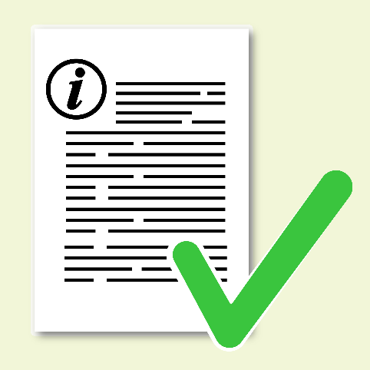 | - personal data must only be available to people involved in recruitment  - keep information accurate and up to date  - follow your Access Panel’s data protection or privacy policy
 | What not to do:  - do not collect personal information you do not need  - do not share personal information with others unless there is a clear and lawful reason  - do not talk about applicants’ personal information when it is not about recruitment
 | - do not leave personal information on shared computers, personal devices or in public spaces  - do not use personal information for things it was not collected for, like marketing

Planning to get new Access Panel members
 | Before telling people about your Access Panel, decide what you want to say, and where best to say it.  Decide if you need:  - clear, accessible materials like posters, leaflets, emails or social media posts
 | - simple wording that explains who you are, what you do, and how people can join  - links to more information or a named contact person
 | - to host a workshop for potential members to come along to and find out about the Panel
 | Ask Disability Equality Scotland for template recruitment materials by emailing: access@disabilityequality.scot
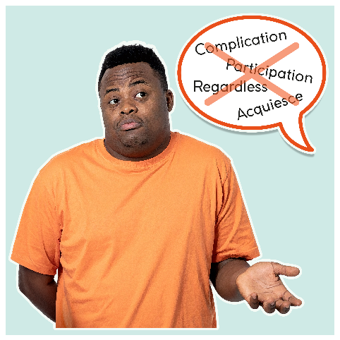 | Helpful hint: having a clear message helps avoid jargon and makes recruitment easier.
 | This is the end of Part 1.  Please now read Part 2.

