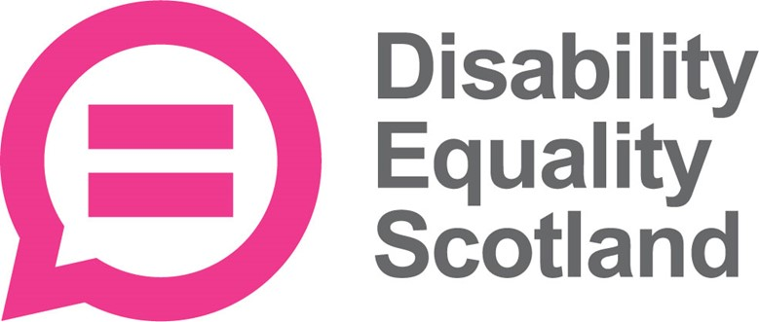

Getting new members to join your Access Panel

Part 2 of 2
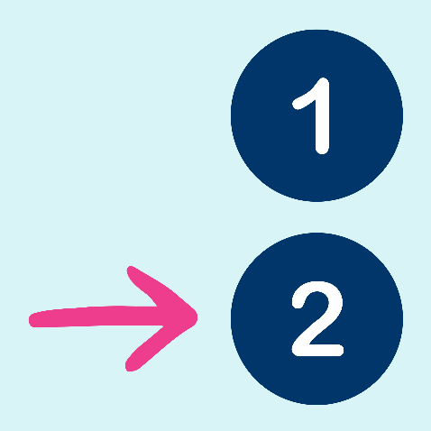
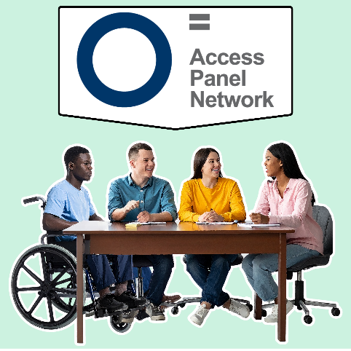
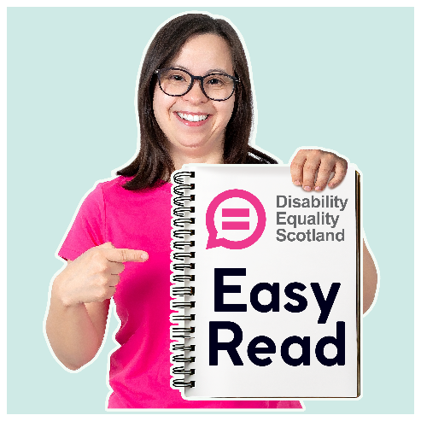

Who this information is for
This information is for Access Panels in Scotland who want to find new members.
This is Part 2.

How to get more people to join your Access Panel
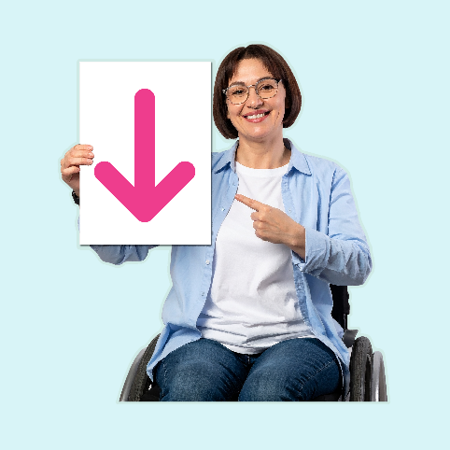 | Here are 5 ways to get more people to join your Access Panel.
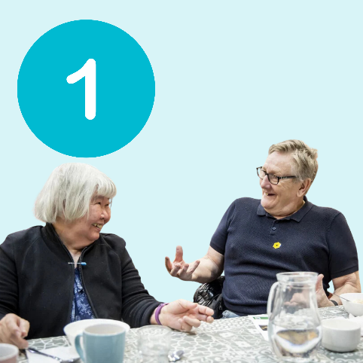 | 1. Asking people directly  You could:  - talk to people you know  - send flyers to local organisations  - have an open day
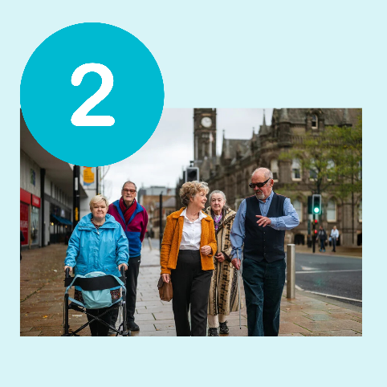 | 2. Asking your community  You could:  - ask your local Volunteer Centre to add your Access Panel’s details  - put posters in libraries, GP surgeries, supermarkets, community centres and cafés  - go to local events to chat to people about joining
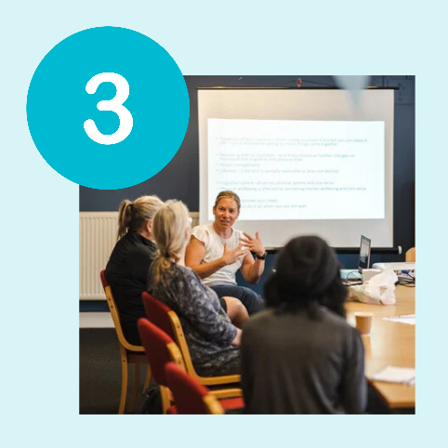 | 3. Focusing on the skill you need in your Panel  You could:  - give a short talk to a community group  - ask for someone with that skill or experience on Facebook  - ask disability organisations, young people’s groups (colleges, universities) or carers’ services
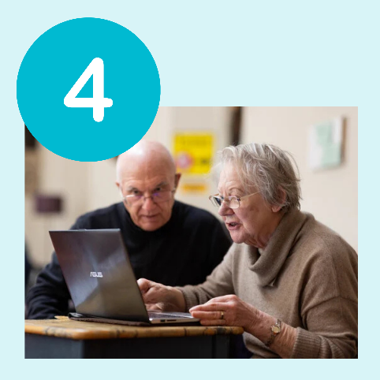 | 4. Using social media  Social media is a collection of websites and apps that lets you share information and pictures online, and chat with others.  Social media can be an easy and cheap way to get more people to join your Access Panel.
 | Facebook is useful for:  - reaching people of all ages  - reaching local communities
 | Instagram is useful for:  - sharing short videos explaining what the Panel does  - reaching younger people and students
 | Bluesky is useful for:  - reaching disability organisations, and campaign groups  - sharing short updates or news about an event
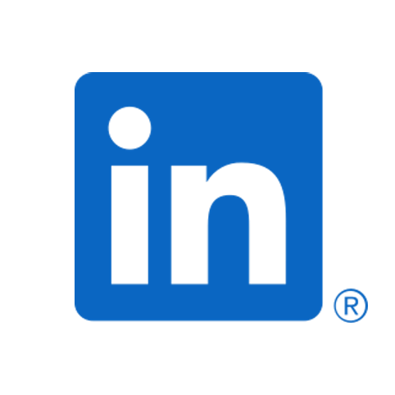 | LinkedIn is useful for:  - reaching professional people who are interested in accessibility  - finding people with skills in computers, design or planning  - reaching local businesses that may want to support the Panel
 | What to post  - a short message explaining who you are and inviting people to join  - photos from your Access Panel events
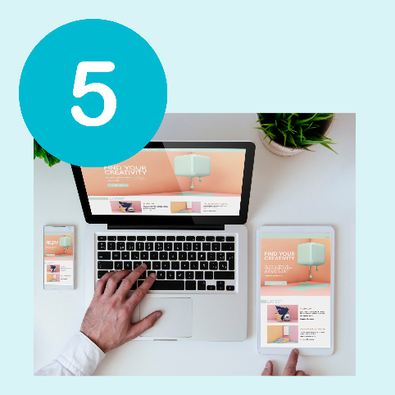 | 5. Posting on different websites  You can reach people by sharing information on websites.  You can also ask other organisations to share your information on their websites.
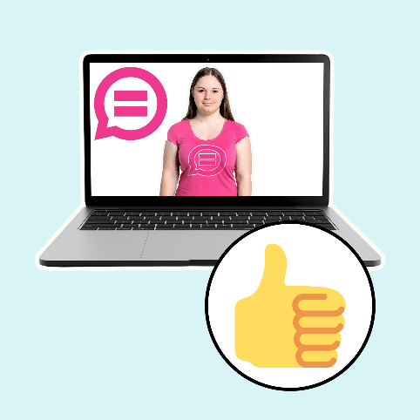 | Disability Equality Scotland Website  Disability Equality Scotland can help Access Panels get new members by putting the advert on:  - the main DES website  - your own Access Panel website  Just email access@disabilityequality.scot
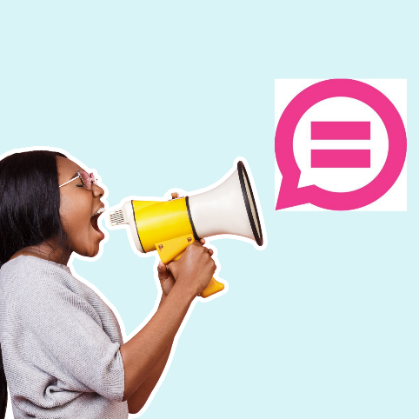 | Other Websites and Newsletters  Many local organisations are happy to help share volunteer messages, including:  - your local council  - disability charities and support groups in your area

What 1 Access Panel did to get more members
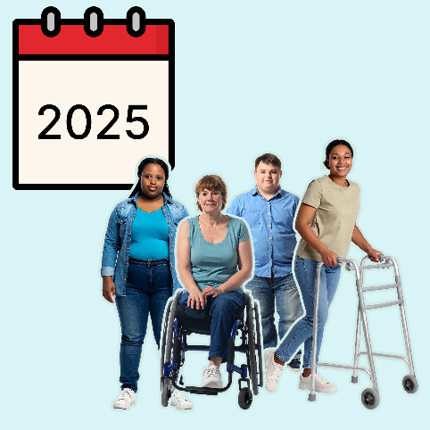 | Badenoch and Strathspey Access Panel welcomed a few new members in 2025.
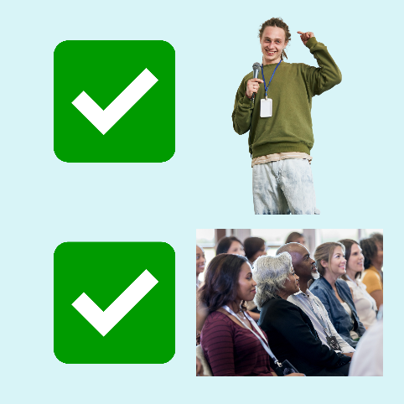 | What they did:  - spoke to local community groups about what the Access Panel does  - had meetings with guest speakers and topics that local people were interested in
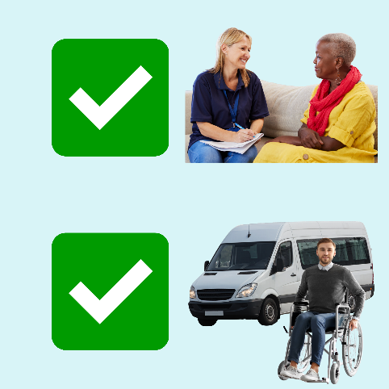 | - made everyone feel welcome at meetings and asked people to leave their email address or phone number  - got a local minibus that carries wheelchairs to help people get to meetings

Keeping things friendly
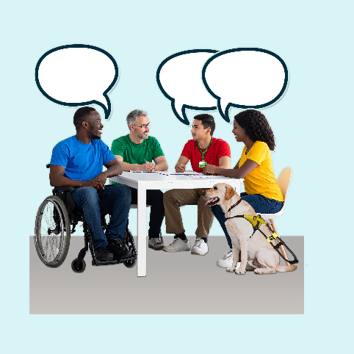 | Be welcoming.  Be flexible.  Be clear and honest.  Find ways so that no one is left out.

More information
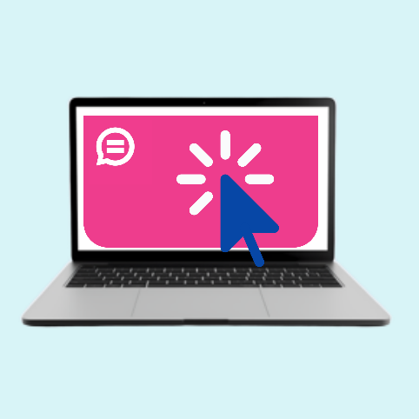 | You can find a list of organisations which might help you get new members.  It is near the end of the main Access Panel Recruitment Pack on our website www.disabilityequality.scot
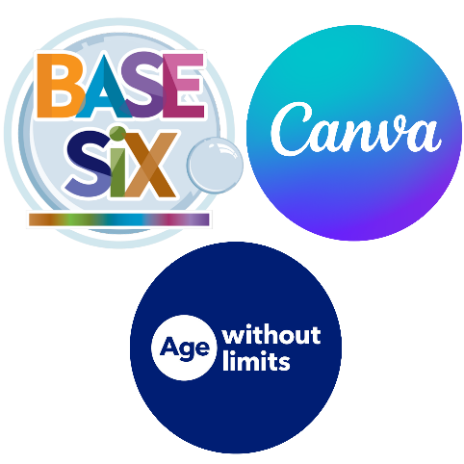 | This is the end of this Easy Read.  In this Easy Read we used pictures from BaseSix, Canva and Age Without Limits.

